Notice of Best Management Practices (BMPs)
CITY OF EL SEGUNDO, COMMUNITY DEVELOPMENT

Permittees and their contractors to implement a program to effectively control water pollution during all Permit construction projects for Stormwater and Runoff Pollution Control:

The Permittee or Authorized Representative and their contractors shall know and fully comply with the applicable provisions of these permits and Federal, State, and local regulations that govern their operations and the storm water discharges from the project site.
To ensure a minimum level of water quality control, the Permittee or Authorized Representative and their contractors shall effectively implement and maintain appropriate Best Management Practices (BMPs).
In addition, the Permittee or Authorized Representative and their contractors shall comply with the following requirements:
- Sediments shall not be discharged to the storm drain system or receiving waters. Sediments generated on the construction site shall be retained.
- No construction-related materials: waste, spills, or residue shall be discharged from the project site to streets, drainage facilities, receiving waters, or adjacent property by wind or runoff.
- Non-storm water runoff from equipment, vehicle washing, or any other activity shall be contained within the project site using appropriate BMPs.
- Erosion from slopes and channels shall be prevented.
- Minimize grading during the wet season (October 15 through April 15). All erosion susceptible slopes shall be covered, planted, or protected in any way that prevents sediment discharge from the project site.

Year-Round Implementation Requirements
The Permittee or Authorized Representative and their contractors shall have an effective program for implementing, inspecting, and maintaining water pollution control practices for wind erosion control, tracking control, non-storm water control, and waste management and materials pollution control.
Soil stabilization and sediment control practices shall be provided throughout the rainy season, defined as between October 15 and April 15, and whenever the National Weather Service predicts rain within 24 hours. The National Weather Service weather forecast shall be monitored and used by the Permittee on daily basis.
The non-rainy season shall be defined as all days outside the defined rainy season. Disturbed soil areas within the project shall be protected in conformance with the requirements in the Construction Site BMP Manual with sediment controls implemented prior to a predicted rain event.

Maintenance and Inspection
The Permittee or Authorized Representative and their contractors shall be responsible throughout the duration of the project for installing, constructing, inspecting, maintaining, removing, and disposing of the BMPs.
Report of Non-Permitted Discharge and Enforcement
If the Permittee or Authorized Representative or their contractors identify any non-permitted discharge into the storm drain system or receiving waters in a manner causing, or potentially causing, a condition of pollution, or if the project receives a written notice or order from any regulatory agency, the Permittee or Authorized Representative or their contractors shall immediately inform the city authorities having jurisdictions. The Permittee or Authorized Representative and their contractors are subject to enforcement action
In addition, the Permittee or Authorized Representative and their contractors are subject to enforcement action by the State Water Resources Control Board (SWRCB), Environmental Protection Agency, private citizens, and citizen groups. The Permittee or Authorized Representative and their contractors shall be responsible for the costs and for liabilities imposed by law as a result of the Permittee or Authorized Representative or their contractor's failure to comply. Costs and liabilities include, but are not limited to, fines, penalties and damages whether assessed by the city against the Permittee or Authorized Representative or their contractors, including those levied under the Federal Clean Water Act and the State Porter Cologne Water Quality Act.

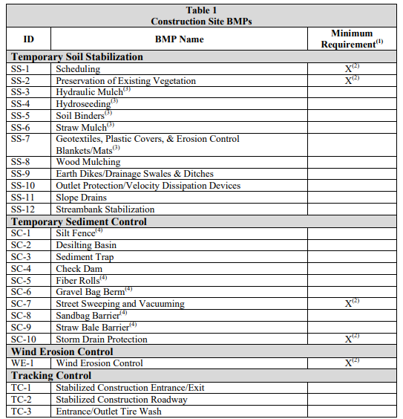

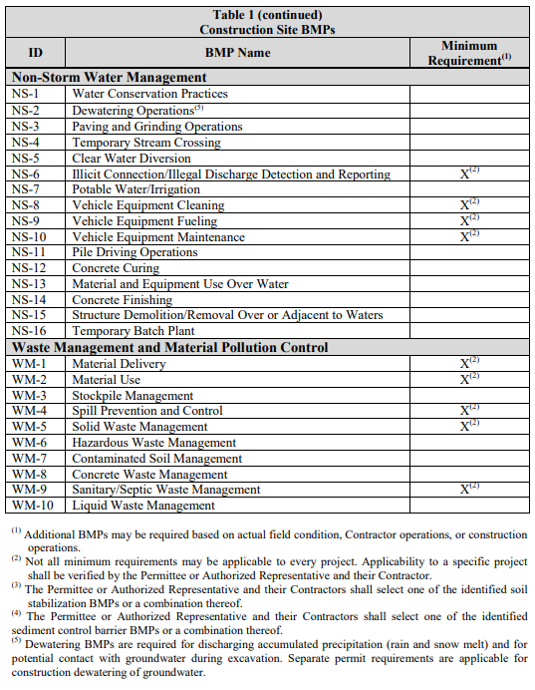

https://dpw.lacounty.gov/spats/public/spatsfaq/forms/BMP Acknowledgement and Attach.pdf

