Revised: August 30, 2021
Location:
1475 E El Segundo Blvd
1320 E Franklin Ave
APN:
4139-002-022
4139-002-025
Applicant/Contact:
Mark Telesz
Smoky Hollow Industries
310-616-5040 x1
Staff Contact:
310-524-2312
planning@elsegundo.org
Standard Works Project (EA-1281 & 1282)
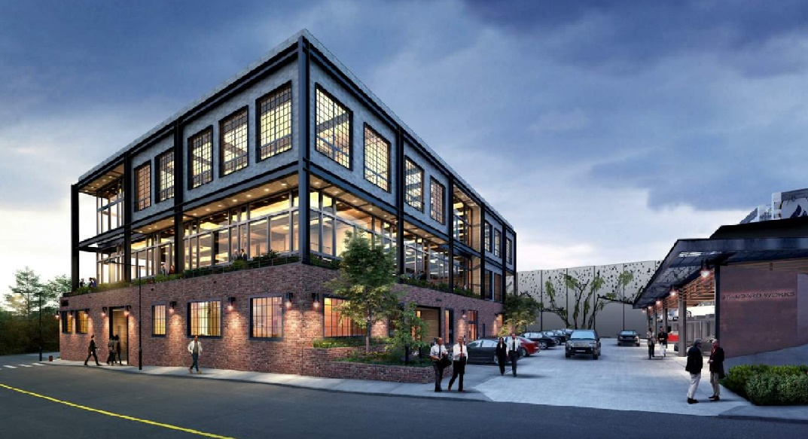

Project Update:
Project Description:
- The proposed Project is located on two adjacent sites within the SHSP area, in the Smoky Hollow East (SH-E) zoning district of the Smoky Hollow Specific Plan.
- A Tier II Community Benefits Plan (CBP) to permit deviations to height and floor area ratio (FAR) standards, for proposed redevelopment of existing structures within the Smoky Hollow East zoning district of the Smoky Hollow Specific Plan (SHSP).
- North Site (1320-1330 Franklin): The project proposes 45,568 square feet (SF) addition to existing 19,493 SF, for a total of 65,061 SF for office uses. Existing building structure will be preserved in place. A new two-story 766 SF coffee kiosk building is proposed on the project site.
- South Site (1475 El Segundo): The project proposes 44,604 SF in addition to existing 19,311 SF, for a total of 63,915 SF for office uses. Existing building structure will be preserved in place.
- A Specific Plan Amendment to modify the Tier II Community Benefit Plan process in a Specific Plan subarea to allow for a maximum height up to 60 feet.
- The application was submitted on January 31, 2020
- Status: Project Review/Entitlements Pending
- Public Hearings: Planning Commission/Council
Council: TBD Fall 2021

Related Documents:
- Development Plans
- Click here to access copy of
  - Smoky Hollow Specific Plan adopted 2018
  - Specific Plan EIR certified in 2018

